01.30.09 – Interactive Map Design Spec

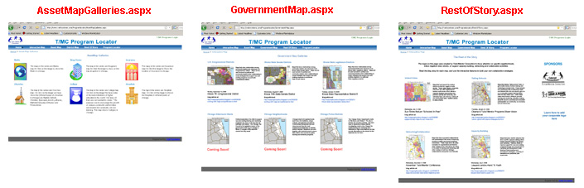

AssetMapGalleries.aspx is fine for now. No changes proposed at the moment. | GovernmentMap.aspx will need to change to the attached layout.  The featured map for each of the categories will change whenever a new map is created in Chicago, and the thumbprint will link to the interactive map, zoomed to the featured district, with that district’s assets displayed.  A link to an associated blog will appear below.  Each time a new map is made, we will send thumbprint .jpg, publication and headline text, blog link, and instructions as to which assets and borders need to be turned on. | RestOfStory.aspx will need to change to the attached layout. Includes a sponsor bar here.  The featured map for each of the categories will change whenever a new map is created in Chicago, and the thumbprint will link to the interactive map, as shown below.  A link to an associated blog will appear below the thumbnail.  Each time a new map is made, we will send thumbprint .jpg, publication and headline text, blog link, and instructions as to which assets and borders need to be turned on.
| | |
| | |
V V V
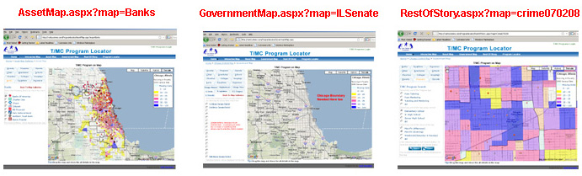
This screen is working properly. | Note that the tabs are the same as the asset map’s, but adds additional tabs for the districts and wards.  I almost think a text box or combo box is a better idea for this (eg. Illinois Senate Districts 1-59) than 59 check boxes. Unless Dan wants to show multiple districts in a given map view.  The Chicago boundary is currently missing. | The taks here allow a user to toggle assets on and off, after initially zooming to the neighborhood featured in the news story, and displaying all relevant assets/ map layers.  New shp files may be sent from Chicago if unique crime location data is needed for the story.  We need to come up with a procedure for getting you everything you need (all images and text and links and shapefiles… as well as which assets and layers should be shown for that particular story) whenever a new map is created.

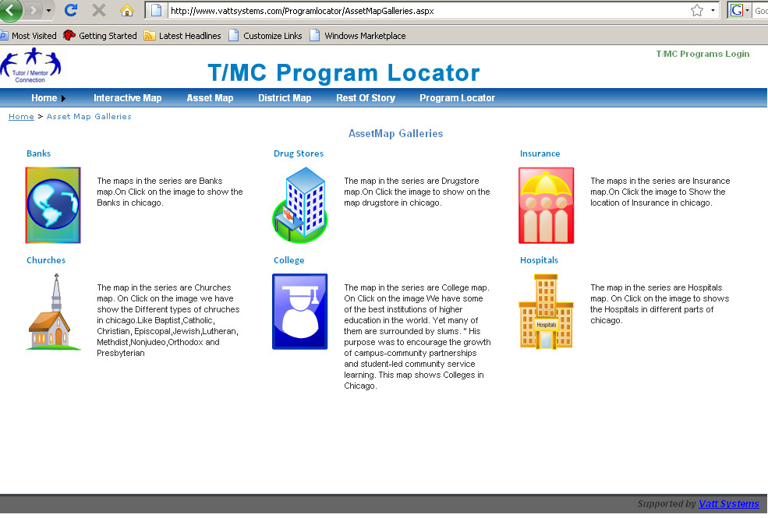
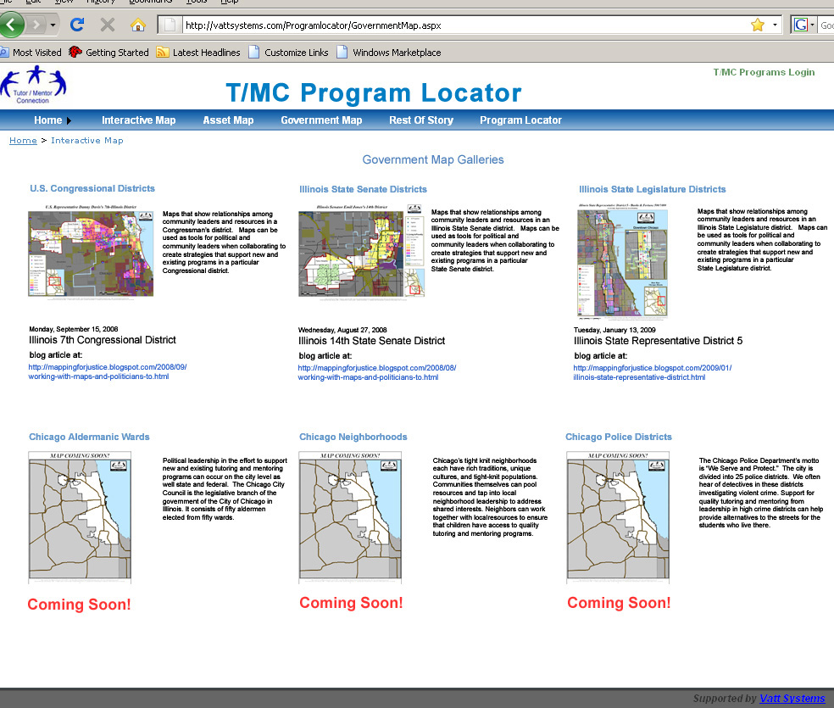
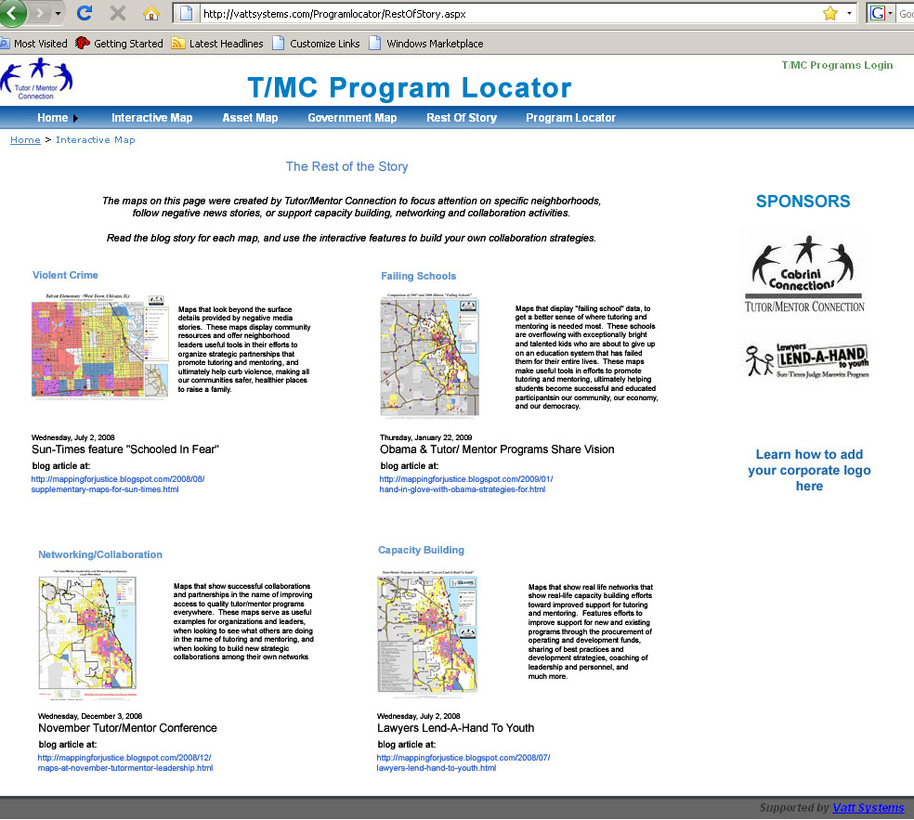
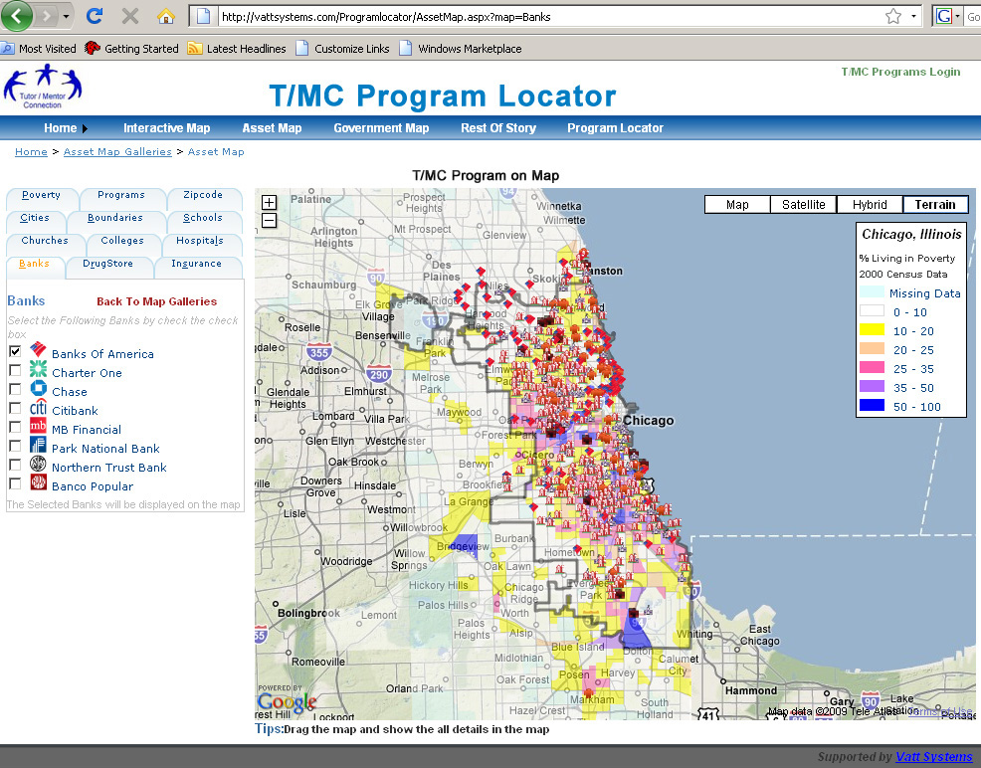
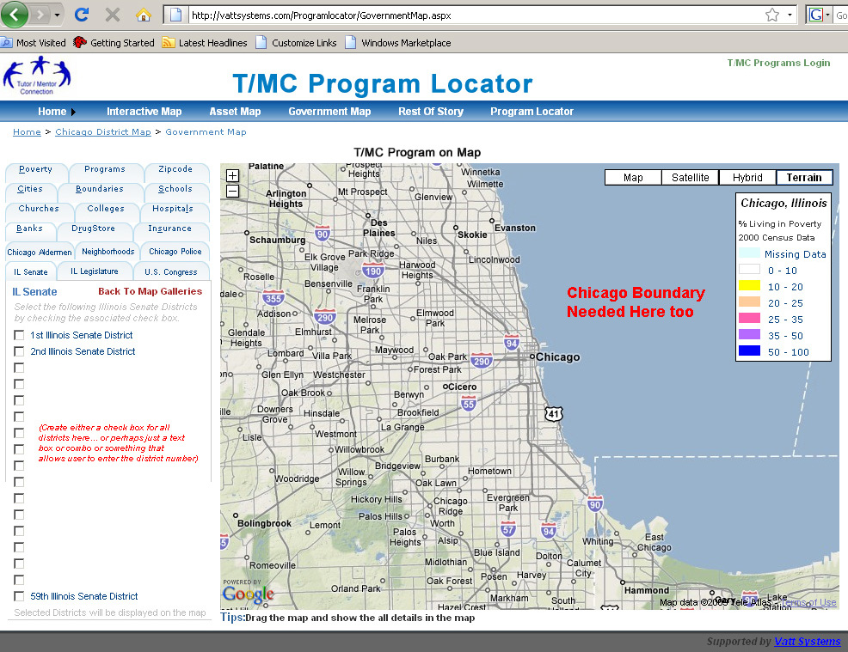
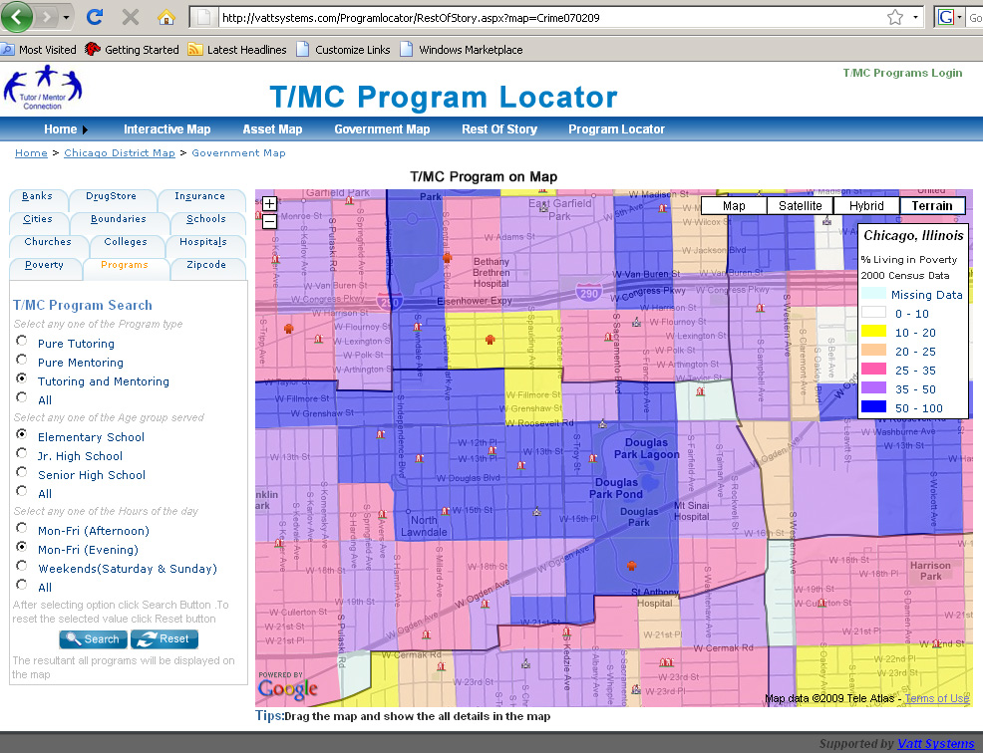

TEXT USED IN SCREEN CAPTURES –TO CUT AND PASTE

REST OF THE STORY TEXT (this is to be featured at top of page)

While the Program Locator can be a great resource, we must find innovative ways to encourage people to find and use the site. One strategy is what we call THE REST OF THE STORY. When local news media feature negative news about violence, poor schools and/or street gangs, we will create maps like you see on t his page that look beyond the surface details provided by negative media stories. These maps show how poverty leads to poor schools and show the locations of existing non-school tutoring and/or mentoring programs in the area, if there are any. Our aim is that people reading the news who want to reduce the violence and improve the schools will use these maps to connect with tutor/mentor programs, as volunteers, leaders and donors. If there are not enough programs in the area, T/MC maps show businesses, faith groups, colleges and hospitals who can be partners in helping new programs grow.

As we post the maps here we will also post them in blog articles that explain the meaning of the maps. We encourage you to copy the JPG files and use them in your own communications, planning and capacity building. Just provide a link from your story to this web site, so more people can view THE REST OF THE STORY

This is text to be shown with each thumnail:

Failing Schools
These maps help you understand where there is the greatest concentration of poorly performing schools, and how poverty has an impact. These are areas where volunteer-based tutoring and mentoring programs needed most. Use these maps to build business and community support that grows tutor/mentor programs in these areas by helping existing programs grow before starting new programs in the same area.

Maps that show successful collaborations and partnerships in the name of improving access to quality tutor/mentor programs everywhere. These maps serve as useful examples for organizations and leaders, when looking to see what others are doing in the name of tutoring and mentoring, and when looking to build new strategic collaborations among their own networks

Maps that show real life networks that show real-life capacity building efforts toward improved support for tutoring and mentoring. Features efforts to improve support for new and existing programs through the procurement of operating and development funds, sharing of best practices and development strategies, coaching of leadership and personnel, and much more.

U.S. Congressional Districts

Maps that show relationships among community leaders and resources in a Congressman’s district. Maps can be used as tools for political and community leaders when collaborating to create strategies that support new and existing programs in a particular Congressional district.

Monday, September 15, 2008
Illinois 7th Congressional District

http://mappingforjustice.blogspot.com/2008/09/working-with-maps-and-politicians-to.html

Illinois State Senate Districts

Maps that show relationships among community leaders and resources in an
Illinois State Senate district. Maps can be used as tools for political and community leaders when collaborating to create strategies that support new and existing programs in a particular State Senate district.

Wednesday, August 27, 2008
Illinois 14th State Senate District

http://mappingforjustice.blogspot.com/2008/08/working-with-maps-and-politicians-to.html

Illinois State Legislature Districts

Maps that show relationships among community leaders and resources in an Illinois State Legislature district. Maps can be used as tools for political and community leaders when collaborating to create strategies that support new and existing programs in a particular
State Legislature district.

Tuesday, January 13, 2009
Illinois State Representative District 5

http://mappingforjustice.blogspot.com/2009/01/illinois-state-representative-district.html

Chicago Aldermanic Wards

Political leadership in the effort to support new and existing tutoring and mentoring programs can occur on the city level as well state and federal. The Chicago City Council is the legislative branch of the government of the City of Chicago in Illinois. It consists of fifty aldermen elected from fifty wards.

Chicago Neighborhoods

Chicago’s tight knit neighborhoods each have rich traditions, unique cultures, and tight-knit populations. Communities themselves can pool resources and tap into local
neighborhood leadership to address shared interests. Neighbors can work together with localresources to ensure that children have access to quality tutoring and mentoring programs.

Chicago Police Districts

The Chicago Police Department’s motto is “We Serve and Protect.” The city is divided into 25 police districts. We often hear of detectives in these districts investigating violent crime. Support for quality tutoring and mentoring from leadership in high crime districts can help provide alternatives to the streets for the students who live there.

